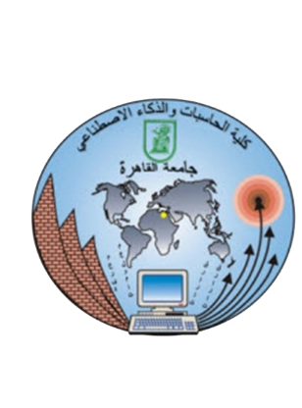

**Faculty of Computers and artificial intelligence**

**Cairo University**

**IS231 – Web technology**

**Web Project Phase 1**

**Submit to: Dr. Neamat El Tazi**

**Project 2 (Online Library website)**

|  |  |  |
| --- | --- | --- |
| Name | ID | Section Num |
| Mohammed Yasser Ismael | **20230365** | **ALL B** |
| Ibrahim Sayed Muhammed Hamza | **20230002** | **ALL B** |
| Karen Ramiz Munier | **20220785** | **ALL B** |
| Mohamed Essam Abdel-Monem | **20230344** | **ALL B** |
| Ziad El-Sayed Muhammed | **20230152** | **ALL B** |
| Mazen Nader Mahgoub | **20220652** | **ALL B** |